RMSC - dev setup guide

1. Create a directory for the workspace where you will checkout the code. I used C:\Workspaces\RMSCWorkSpace

2. Start Dimensions 10.1.2 Desktop Client with below values.

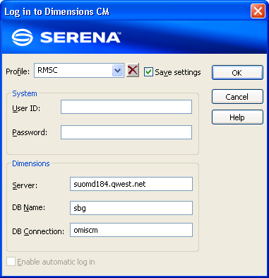

3.Open lastest rmsc workset in dimensions:

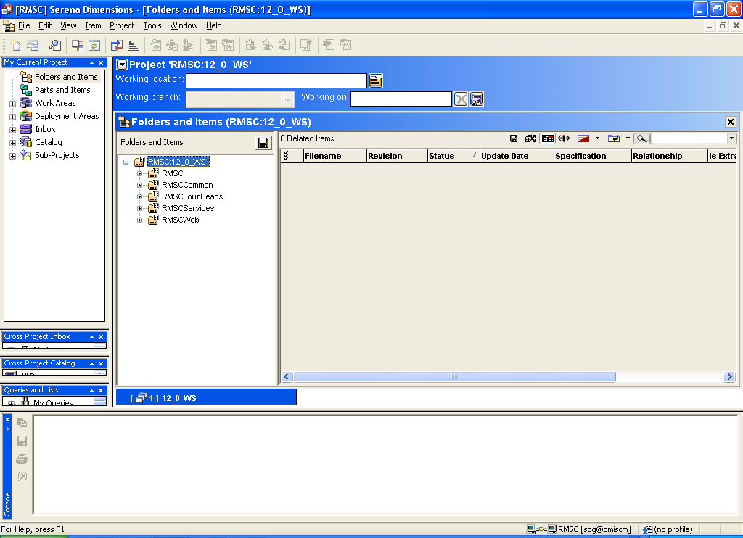

4. Highlight top-level folder and select Get (recursive):
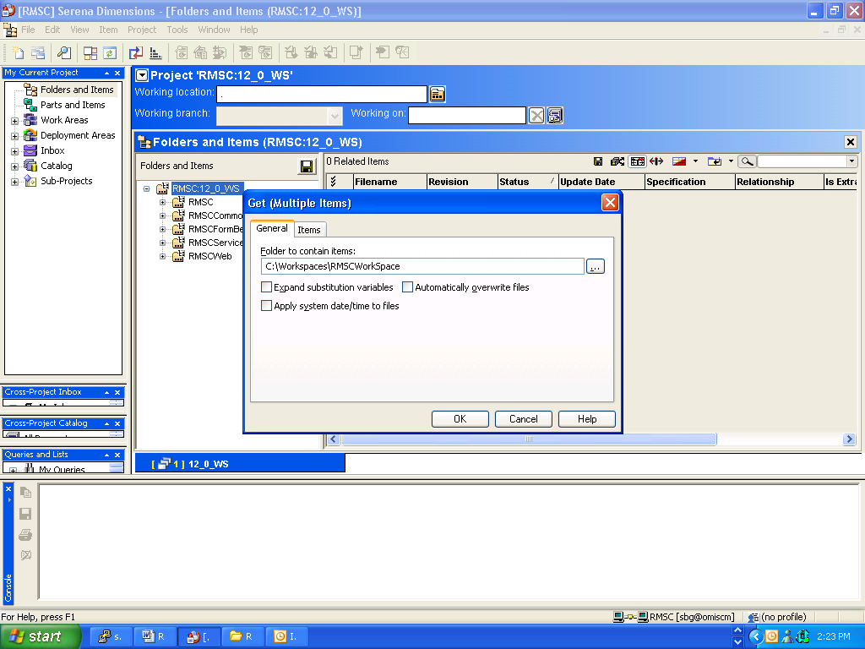

7. Open eclipse and enter workspace (as created in step 1):
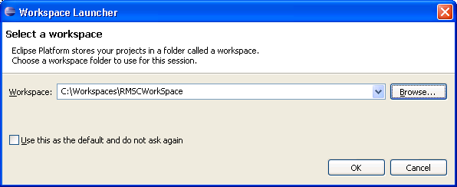

8. Import workspace: File>Import
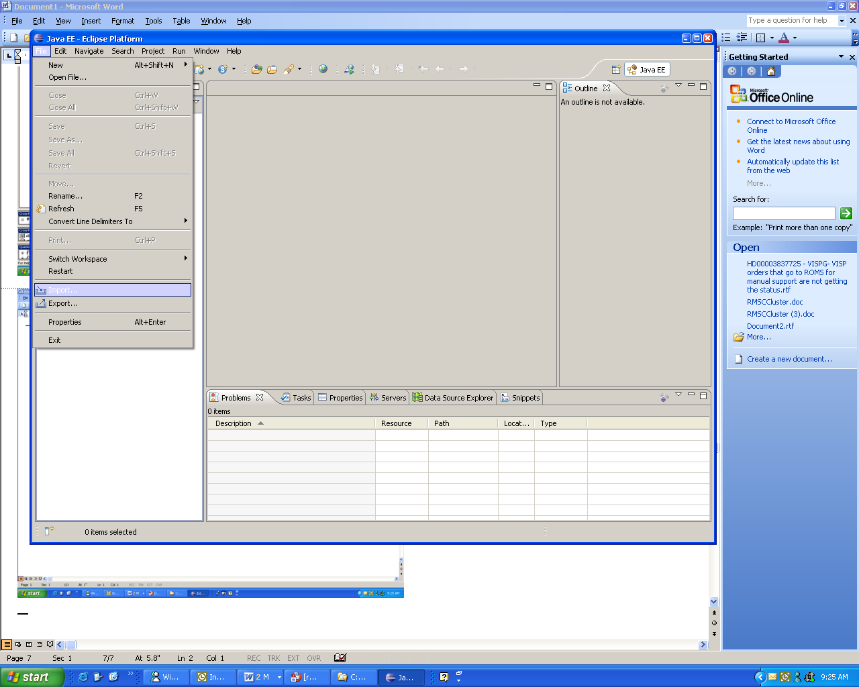

9. Select General>Existing Projects into Workspace. Enter ‘Next’.
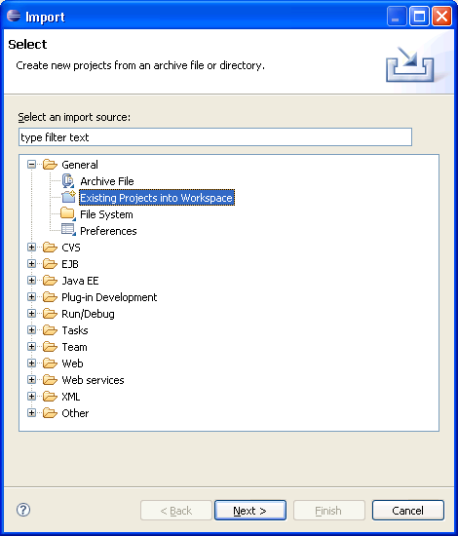

10. Enter workspace created in step 1, ensure all projects checked. Select ‘Finish’.
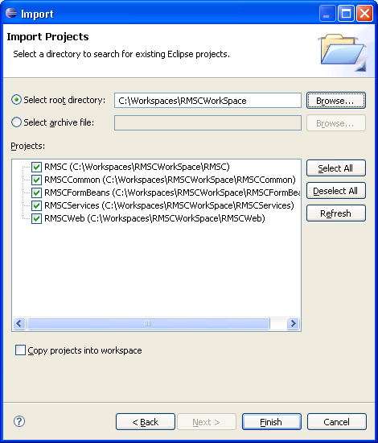

11. May see this popup. Click ‘Finish’.
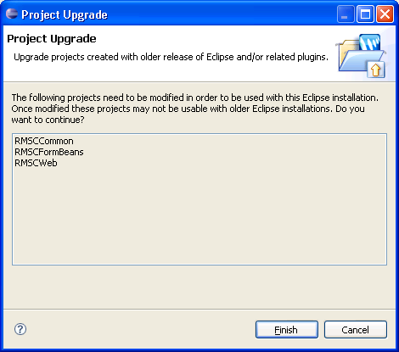

12. Navigate to Windows>Preferences in eclipse main menu.

13. Expand Ant>Runtime. Select Properties tab. Enter ‘Add Property’ button. Enter values env, dev as below. Enter ‘Ok’.
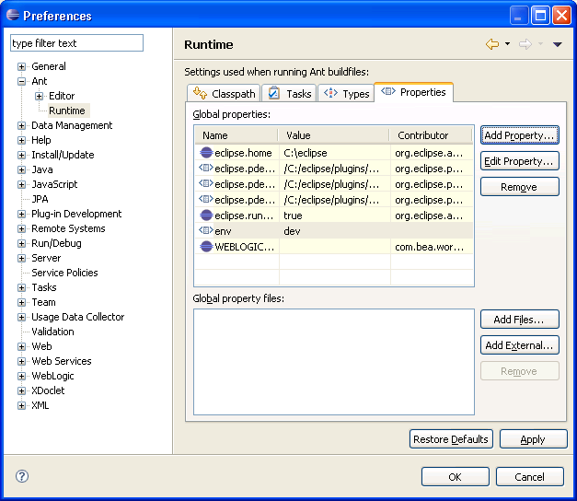

14. Expand Java>Installed JREs. Select ‘Add’ button. Highlight ‘Standard VM’ in popup. Select ‘Next’.
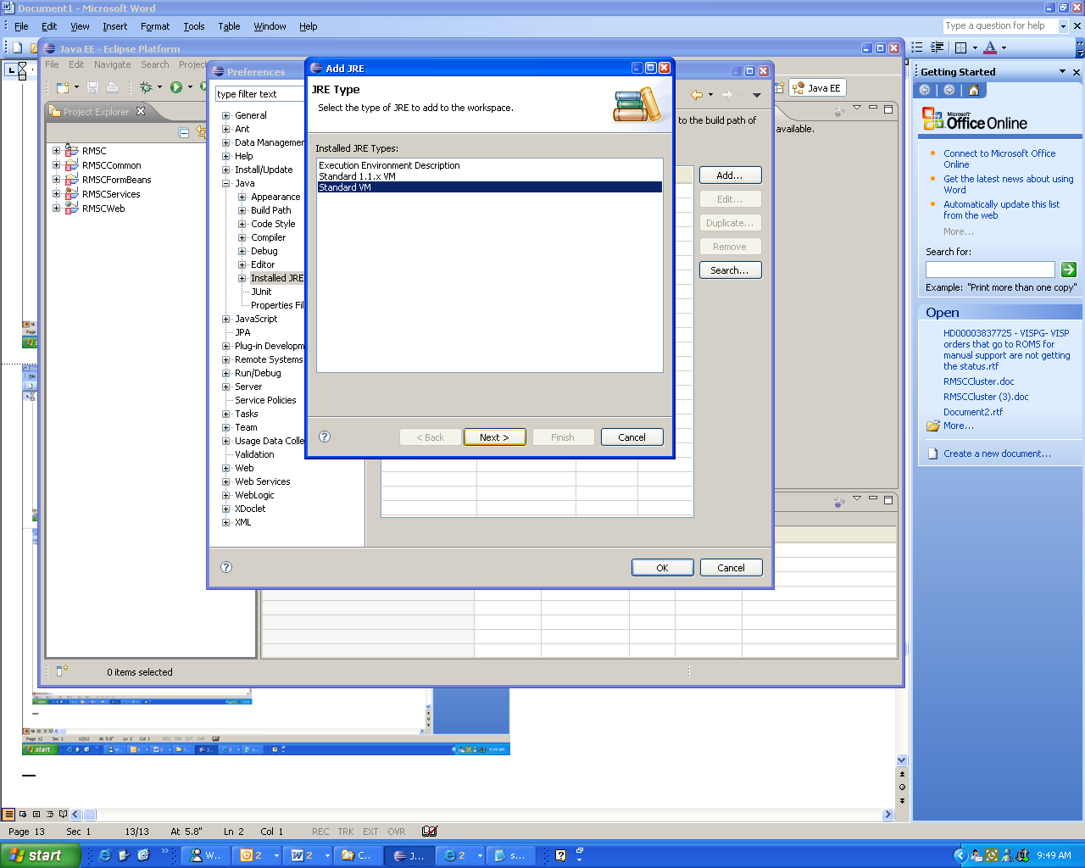

15. Make sure the default JRE is the jrockit JRE from BEA 10 directory. The jrockit checkbox should be checked.

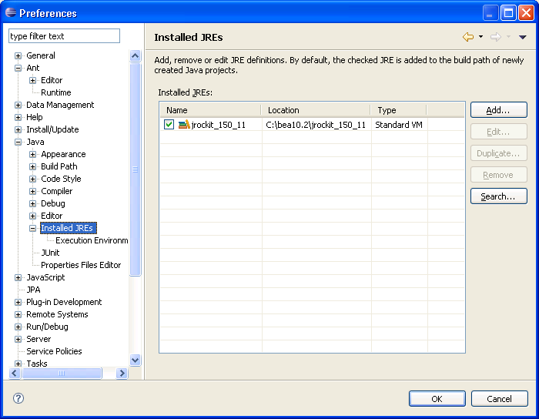

17. Expand Server>Runtime Environments. Click the Add.. button

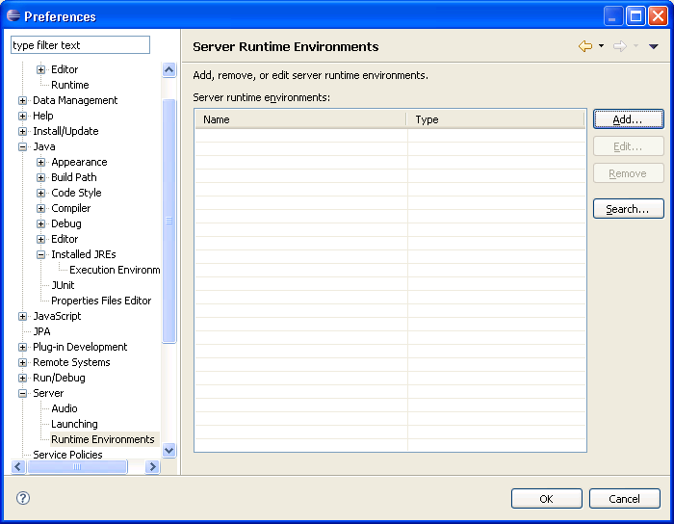

In popup, expand BEA Systems, Inc.>BEA WebLogic Server v10.0. Click ‘Next’.
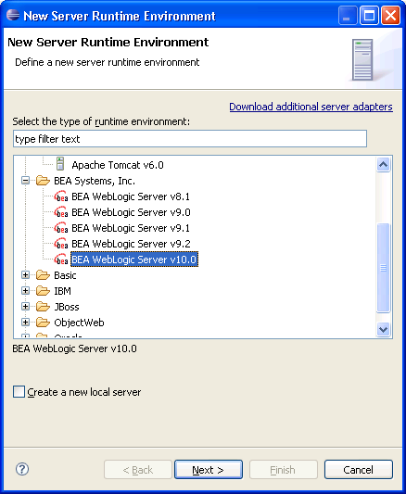

18. Enter ‘Finish’.
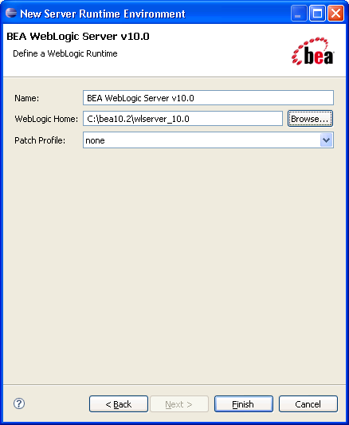

19. In Project Explorer pane in eclipse, navigate to RMSC -> deploy -> env. Edit env.properties.dev and modify the parameters in the file to point to the correct BEA install location and the location for your workspace and domain.

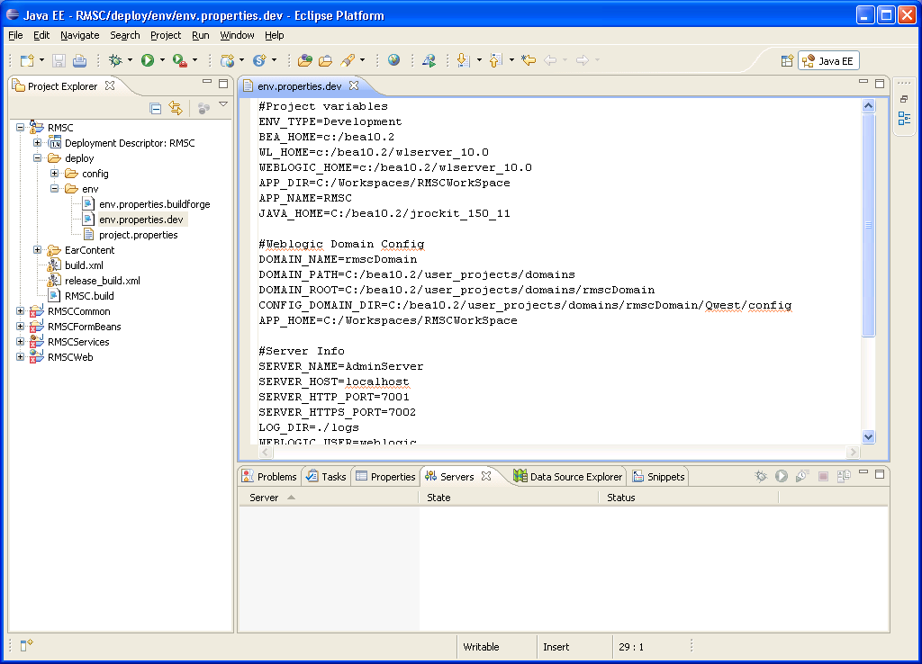

Some values I had to change are APP_DIR and APP_HOME to workset as created in step 1.

23. Run build. Highlight release_build.xml. Select Run As>Ant build.
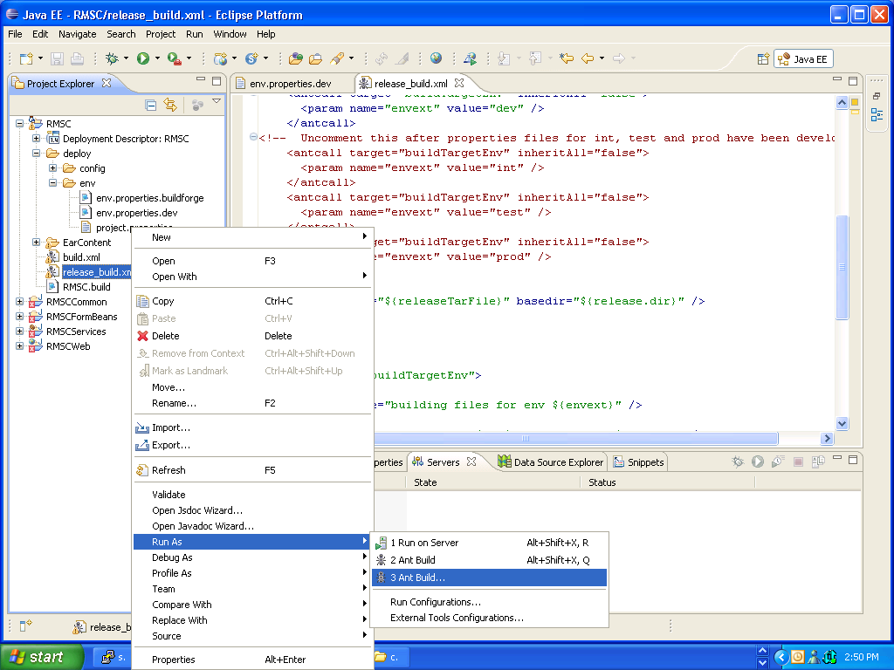

24. Ensure ‘release[default]’ checkbox checked. Select ‘Run’.
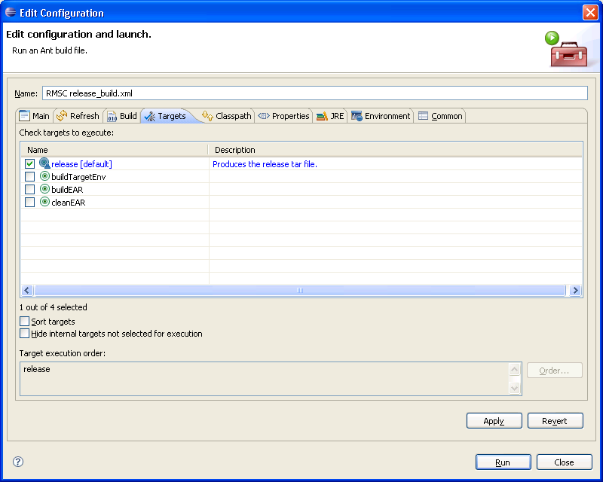

Look at the eclipse console and make sure you see BUILD SUCCESSFUL message.

- In the project explorer pane in eclipse, click on ‘RMSC’ and enter F5 to refresh project. You should see the following:
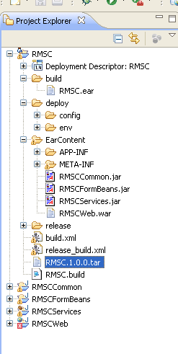

- Create new server. Select Server tab, right click. Select New>Server.
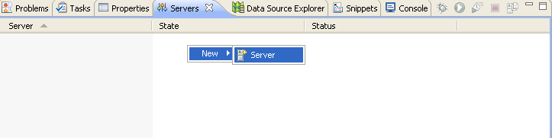

- Highlight BEA WebLogic Server v10.0 and enter ‘Next’:
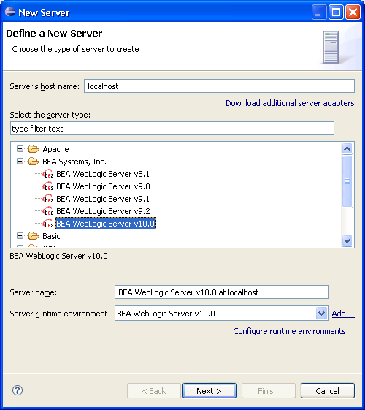

- Browse to domain and select ‘Finish’:
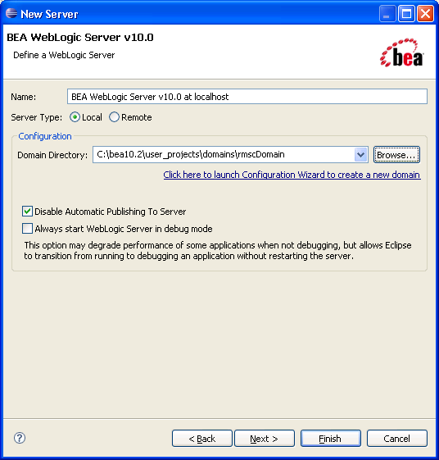

- Start server by highlighting server instance. Right Click and select Start

- Next follow the instructions in RMSCDevelopmentCluster.doc file to create a cluster in your development environment and deploy the application.

